Processing Timecards - Approvers

This document is intended for use by designated timecard approvers. The purpose of this document is to provide instruction on how to approve employee timecards (weekly) and run the weekly plug.
Once logged into the ERP system, you should navigate to the ERP entry point ‘Timecard Approval’.

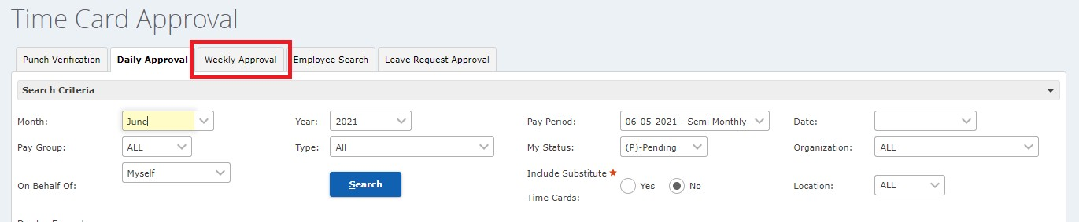

- From the Daily Approval tab, click the Weekly Approval tab.

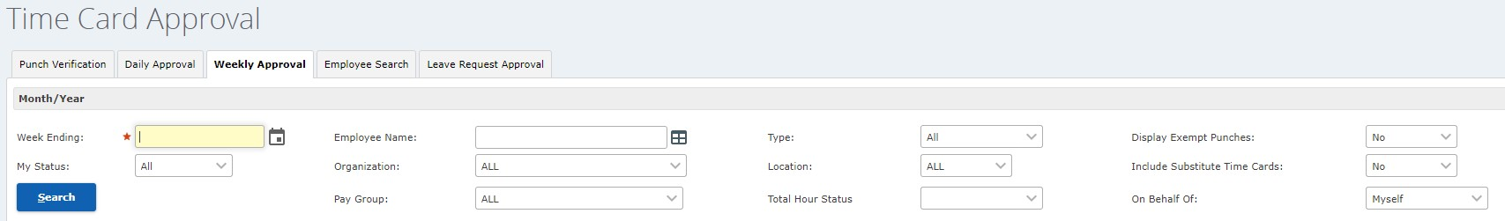

- Enter any date within the week you want to approve and click the Search button. (This field will update to show the last day of the week selected after clicking Search. Pasadena’s week for FLSA reporting runs from Monday-Sunday.)

- If you are designated as the backup approver, click the dropdown arrow in the field On Behalf Of and choose the approver’s name.

- Now you will review the timecards built by the timecard editor.
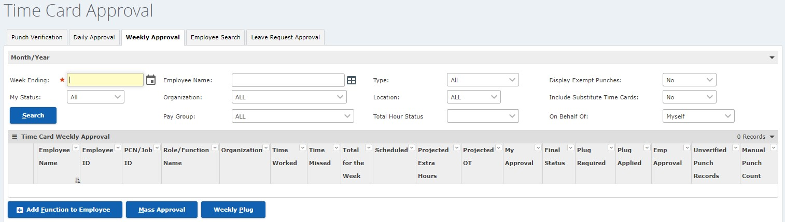

My Approval: Indicates if you have approved all of the timecards for the week. If any timecards are still P (Pending), the week is considered to be Pending. A status of A (Approved) is required for payroll processing.
Final Status: Indicates if the timecard has been approved by everyone in the workflow. If any timecards are still P (Pending), the week is considered to be Pending.
Emp Approval: Indicates if the employee has reviewed and signed off on the timecard by clicking the Approve button on the My Timecards page in the Employee Service Center (ESC).
NOTE: Whether timecards are approved by employees does not affect payroll. Employees can approve timecards at any time.
Unverified Punch Records: The number of punch records with a status of Unverified for the employee for the selected week. If there are any unverified punches, the weekly plug cannot be run to complete the approval process. Your Timecard Editor will need to process these records before you complete your approval.

- There are two important steps in your approval process.
Mass Approval: To approve all timecards displayed in the list, click the button. This will approve all timecards that do not exceed the 2-hour Approval Hours Threshold.
  - For timecards that exceed the Approval Hours Threshold business rule, click on each individual employee’s name to view the weekly summary page. You can approve timecards from this screen.

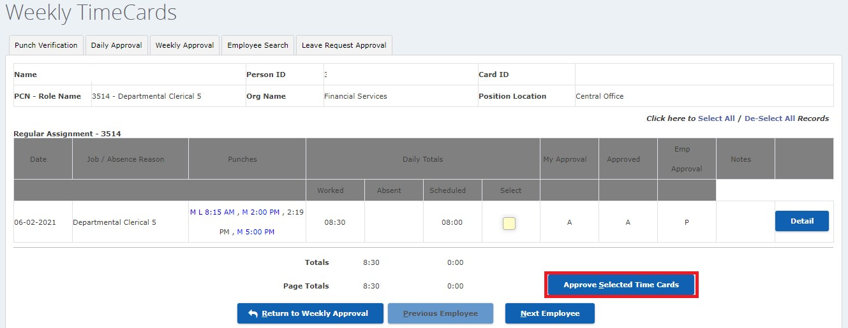

Weekly Plug: This is required if the Weekly Plug Required message is flashing yellow at the top of the screen. The Weekly Plug button creates a timecard that covers the difference between the amount of time the employee has worked (Total for the Week) and the amount of time he or she is scheduled to work (Scheduled Hours). Employees whose Total for the Week amount is less than their Scheduled Hours amount will show YES in the Plug Required column.

Once the week is complete and employee timecards have been approved, click the button. The weekly plug will apply to all employees who:
  - are currently displayed on the page based on the search criteria you entered,
  - have all of their timecards for the week approved in the Final Approval column, and
  - have Yes in the Plug Required column.
The system creates an absence for the hours created by the plug. The absence hours come out of the employee's leave buckets and this ensures that annualized hourly employees account for all their hours. After you click the Weekly Plug button, the Plug Applied column shows YES.

